# Algorithm for file updates in Python

## Project description

As a security analyst in an organization I was given the task to restrict content with an allow list of IP addresses. A file “ allow_list.txt” was given with those addresses. In the other hand, there is another list with IP addresses that should not be accessed to the content called “ remove_list ”. An algorithm was created to automate the updating of the first file and remove the IP addresses that should not have access.

## Open the file that contains the allow list

## Read the file contents

## Convert the string into a list

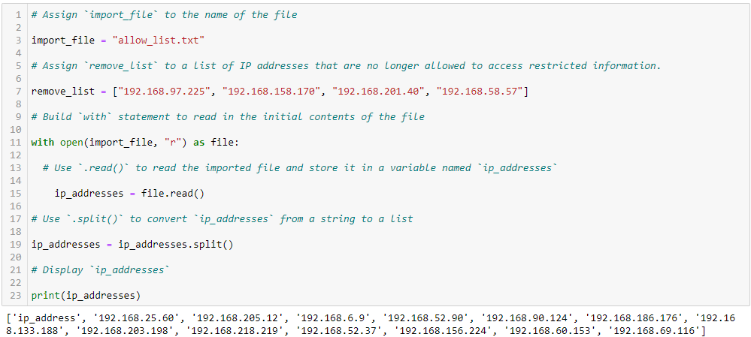

## Iterate through the remove list

## Remove IP addresses that are on the remove list

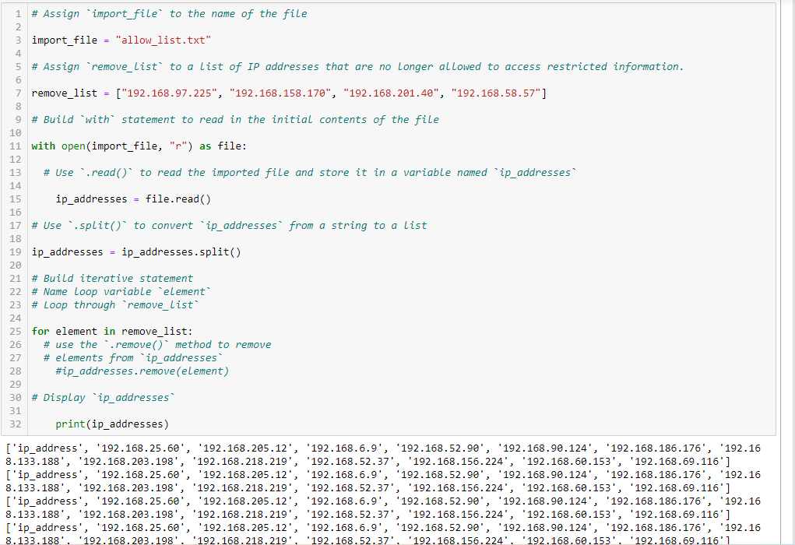

## Update the file with the revised list of IP addresses

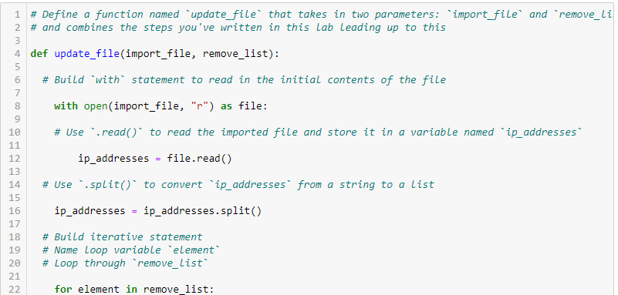

## 

## Summary

In this activity I create an algorithm that removes IP addresses from a specific list of a file( “allow_list.txt”).

To perform this it is necessary to use the functions to open a file, read a file, convert an string to a list, and remove items from a list. Finally, as required by the instructions, the list of ip addresses was converted back into a string and overwritten with the revised list of IP addresses.